CompareTo() method
The compared to methods are used to compare TWO OBJECTS and not two primitive data types. The output of the compared to the method is explained on the basis of some arguments. If we want to compare two primitive data types, we have to use Wrapper class as studied earlier and convert it to objects.
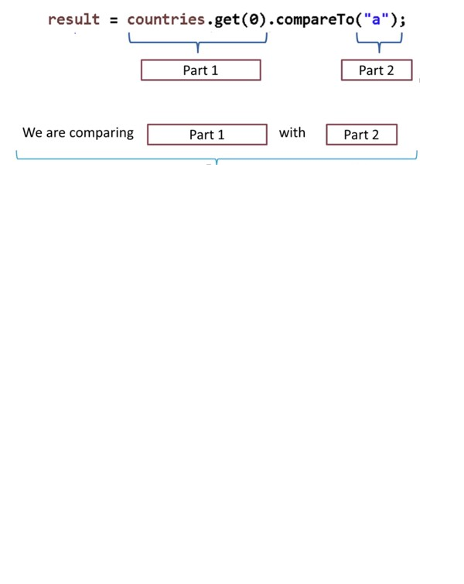
Let’s understand the compareTo() method by the following table:
Description | Result
If Part 1& Part 2 are same | 0
If Part 1 is greater than Part 2 | 1
If Part 1 is smaller than Part 2 | -1

Part 1 | Part2 | Result
1 | 1 | 0
2 | 1 | 1
1 | 2 | -1

In the following program comparTo() method compares two Integer object. This method returns the value 0 if both Integer is equal else it only results either negative or positive value.
public class App {
public static void main(String[] args) {

Integer a = 5;
Integer b = 3;

System.out.println(a.compareTo(b));

}
}
Output
1
Comparable Interface
Comparable Interface is used to sort the custom type objects. By default, a class defined by the user is not comparable. Hence, their objects cannot be compared. To make an object comparable, the class must implement a comparable interface.
The comparable interface can be used to achieve a single way of sorting like ascending or descending sorting the numerical collection or alphabetical sorting for string object collection.
In the following program, class data implements Comparable interface. Implement the unimplemented compareTo() method based on the length of the String variable. This method accepts an object of same instance type and based on certain criteria defined, it returns a negative value if the current value is less than the value we are comparing with, respectively.
class Names implements Comparable<Names> {
private String name;
public Names(String name) {
this.name = name;
}
@Override
public int compareTo(Names obj) {
if (name.length() == obj.name.length()) {
return 0;
} else if (name.length() < obj.name.length()) {
return -1;
} else {
return 1;
}
}
@Override
public String toString() {
return name;
}
}
public class App {
public static void main(String[] args) {
List names = new LinkedList<>();
names.add(new Names("Johnson"));
names.add(new Names("Ed"));
names.add(new Names("John"));
names.add(new Names("Ria"));
App app = new App();
app.printList(names);
Collections.sort(names);
System.out.println("******************");
app.printList(names);
}
void printList(List<Names> list) {
ListIterator<Names> iterator = list.listIterator();
while (iterator.hasNext()) {
System.out.println("Element: " + iterator.next());
}
}
}
Question: Sorts the list elements on the basis of name length in reverse order(modify the implementation of compareTo() method).
Custom sorting using a comparator:
Custom sorting using a comparator is used to order the user-defined methods
To sort the data of this custom type a comparator interface is implemented with custom logic. It will sort the data on key order.
Example 1:
class Data<K, V> {
private K key;
private V value;
public Data(K key, V value) {
this.key = key;
this.value = value;
}
public K getKey() {
return key;
}
public V getValue() {
return value;
}
@Override
public String toString() {
return "Data [key=" + key + ", value=" + value + "]";
}
}
public class App {
public static void main(String[] args) {
Comparator<Data<Integer, String>> COMPARE_KEY = new Comparator<Data<Integer, String>>() {
@Override
public int compare(Data<Integer, String> obj1, Data<Integer, String> obj2) {
if (obj1.getKey() < obj2.getKey()) {
return -1;
} else if (obj1.getKey() > obj2.getKey()) {
return 1;
} else
return 0;
}
};
Set<Data<Integer, String>> set = new TreeSet<>( COMPARE_KEY);
set.add(new Data<Integer, String>(1, "Johnson"));
set.add(new Data<Integer, String>(5, "Ed"));
set.add(new Data<Integer, String>(9, "John"));
set.add(new Data<Integer, String>(2, "Arnold J"));
set.add(new Data<Integer, String>(5, "Mia"));
set.add(new Data<Integer, String>(1, "Johnson"));
for (Data<Integer, String> element : set) {
System.out.println(element);
}
}
}
Example 2:
import java.util.ArrayList;
import java.util.Collections;
import java.util.Comparator;
class Student {
int rollno;
String name, address;
// Constructor
public Student(int rollno, String name, String address) {
this.rollno = rollno;
this.name = name;
this.address = address;
}
// Used to print student details in main()
public String toString() {
return this.rollno + " " + this.name + " " + this.address;
}
}
class Sortbyroll implements Comparator<Student> {
// Used for sorting in ascending order of roll number
public int compare(Student a, Student b) {
return a.rollno - b.rollno;
}
}
class Sortbyname implements Comparator<Student> {
// Used for sorting in ascending order of name
public int compare(Student a, Student b) {
return a.name.compareTo(b.name);
}
}
class Main {
public static void main(String[] args) {
ArrayList<Student> ar = new ArrayList<Student>();
ar.add(new Student(111, "bbbb", "london"));
ar.add(new Student(131, "aaaa", "nyc"));
ar.add(new Student(121, "cccc", "jaipur"));
System.out.println("Unsorted");
for (int i = 0; i < ar.size(); i++)
System.out.println(ar.get(i));
Collections.sort(ar, new Sortbyroll());
System.out.println("\nSorted by rollno");
for (int i = 0; i < ar.size(); i++)
System.out.println(ar.get(i));
Collections.sort(ar, new Sortbyname());
System.out.println("\nSorted by name");
for (int i = 0; i < ar.size(); i++)
System.out.println(ar.get(i));
}
}

